Lab-Setups -- CodePipeline
1. Prepare the Env for Codepipeline
2. Create Codepipeline with 5 stage.
Source -> Approval --> Deploy to test Env --> Approval --> Deploy to Prod env
3. Update the Source S3 ZIP file.

Architecture diagram
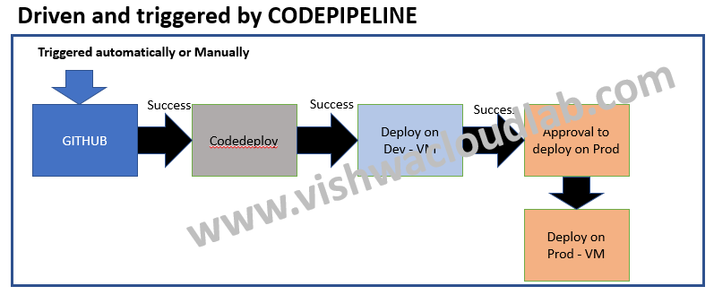

Step1: Prepare the Env for CodePipeline
- Create 2 IAM Policies ,
  - Provide – S3 – get and list Permission for the EC2 instance. -- EC2-codedeploy
  - Provide – Full Ec2 Access for the CodeDeploy -- CodeDeploy
Create Roles ,eg: -- EC2-codedeploy and CodeDeploy
- Create "2" Ec2 instance with “EC2-codedeploy” Roles attached to it.
first EC2 instance name --> testvm01
2nd EC2 instance Name --> prodvm01
- Upload the “Sample-linuz.zip” into S3 bucket and give “Public” access
- Install the Codedeploy agent on both the EC2 instances.
- Create an CodeDeploy "Application"
And Create 2 different Deployment Group for each of the EC2 instance separately.
TWO Deployment Group,
One for the Dev EC2 instance
Second for the Prod EC2 instance

Step2: Create CodePipeline
1. 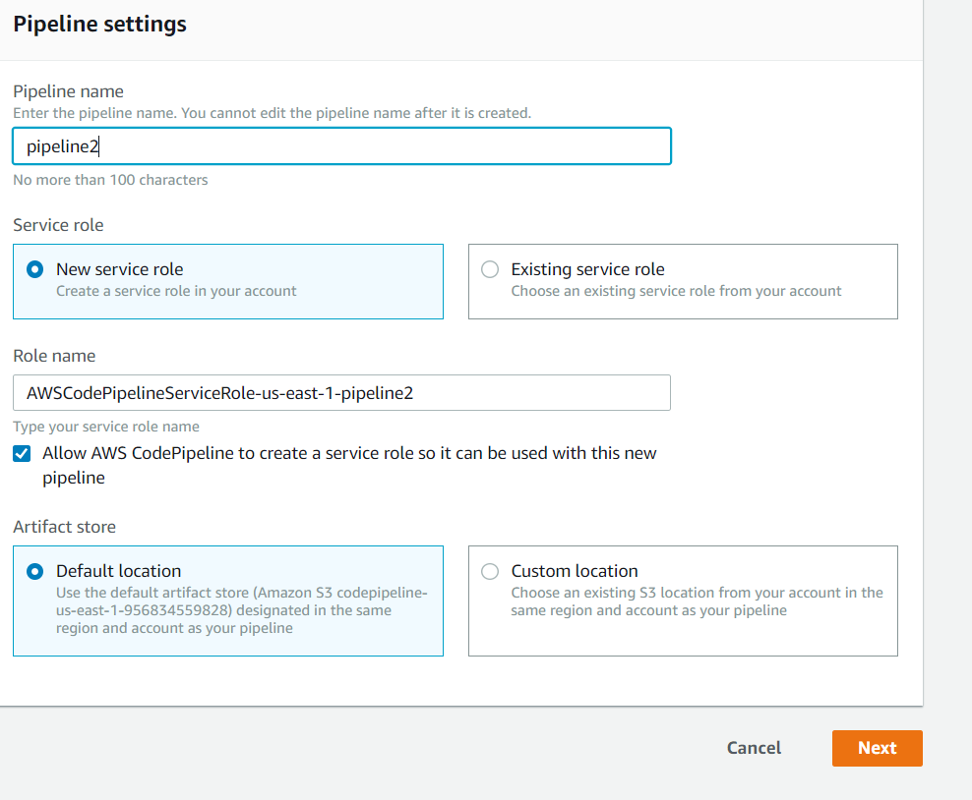
www.vishwacloudlab.com

2. 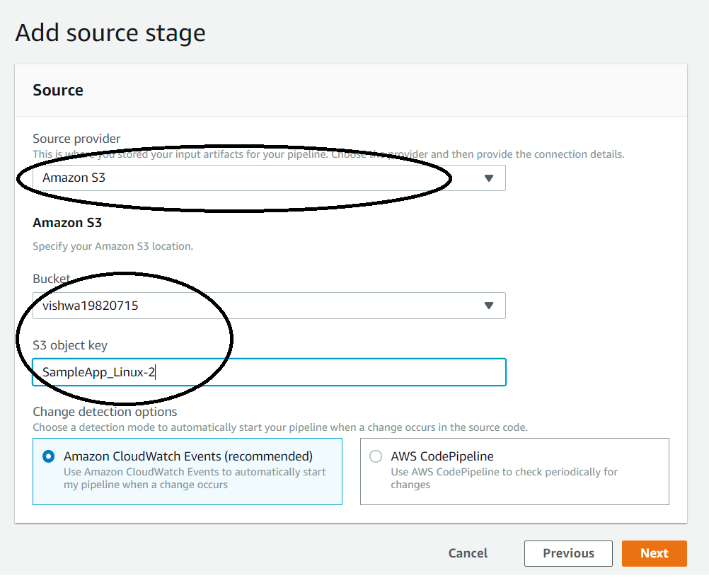
www.vishwacloudlab.com
In Our Scenario we would be skipping the Build Stage, as on the below screen
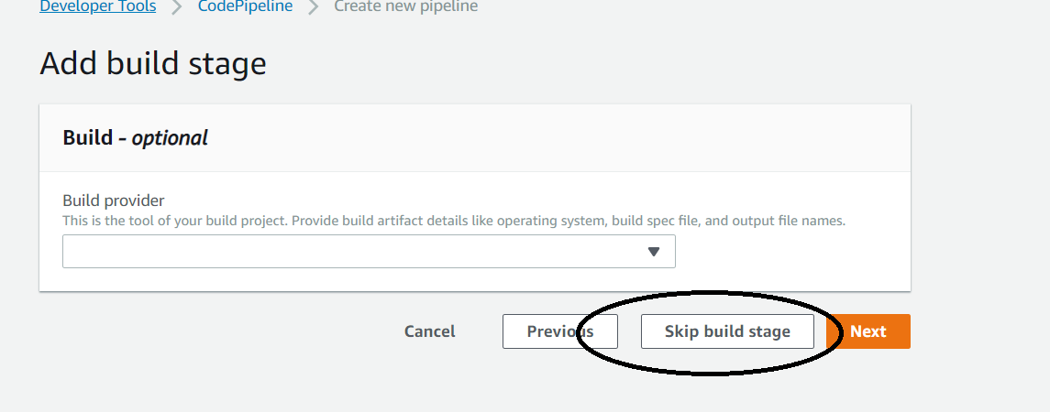
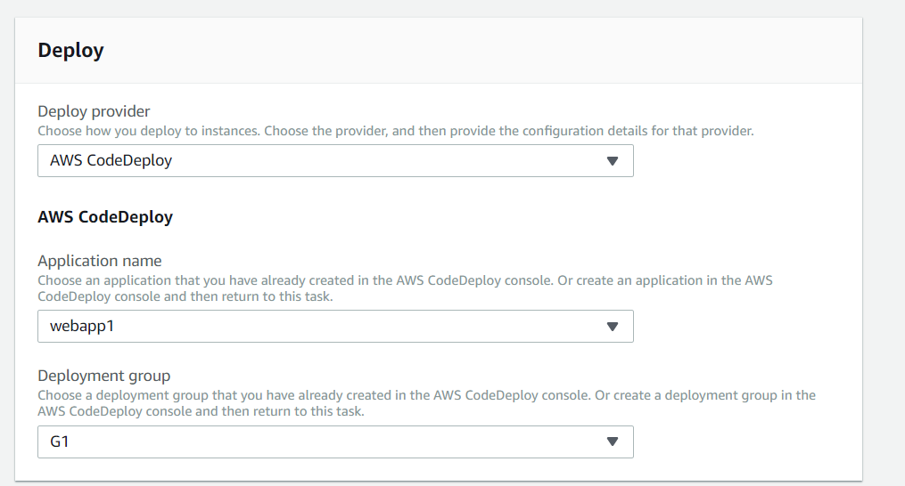
www.vishwacloudlab.com
On the Above screen, select the Codedeploy group created with "testvm01"

Next review and Create the pipeline.
The intermediate steps are added after the Codepipeline is created.
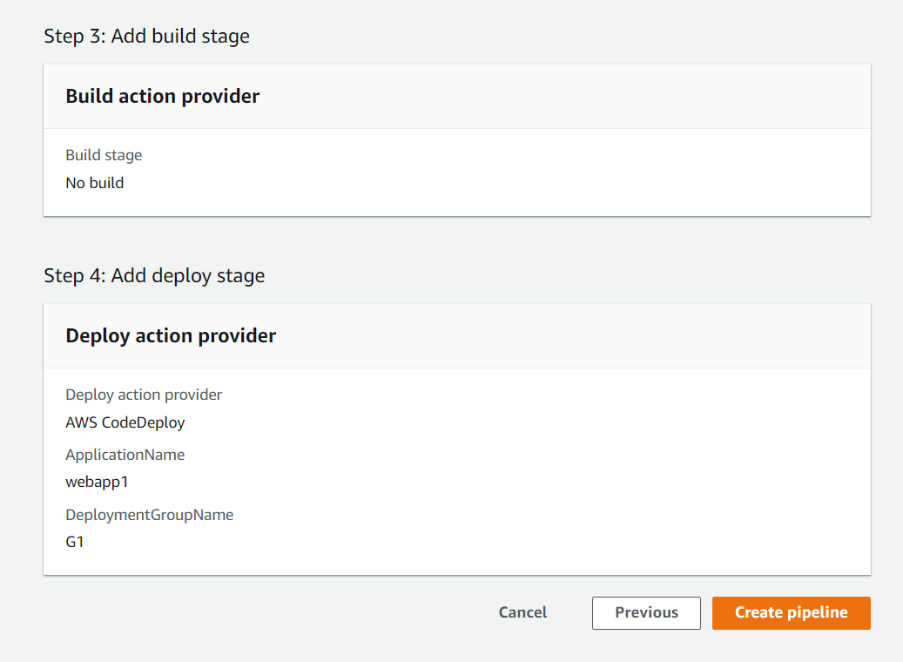
www.vishwacloudlab.com

Now once its created , update the "codepipeline"
Click on the "Edit"
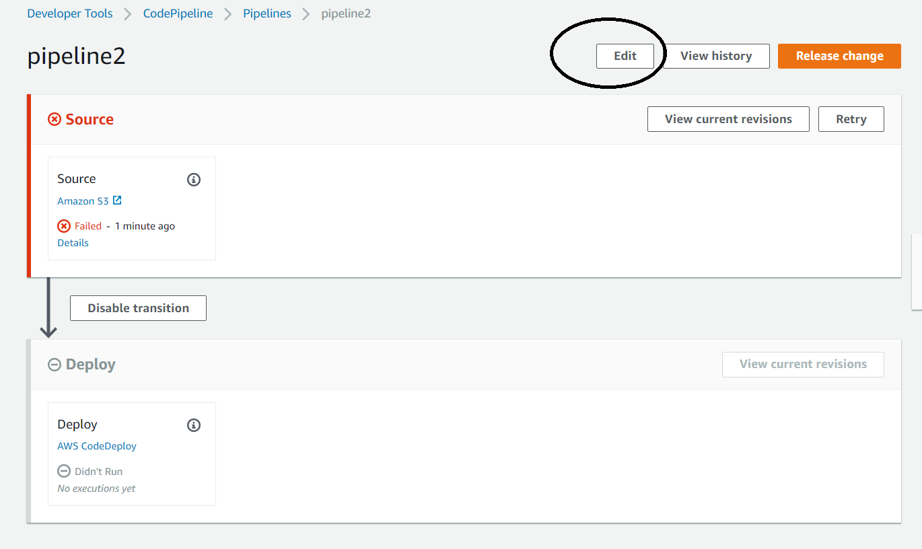
www.vishwacloudlab.com
Click on "Add Stage" to add an "Approval" stage
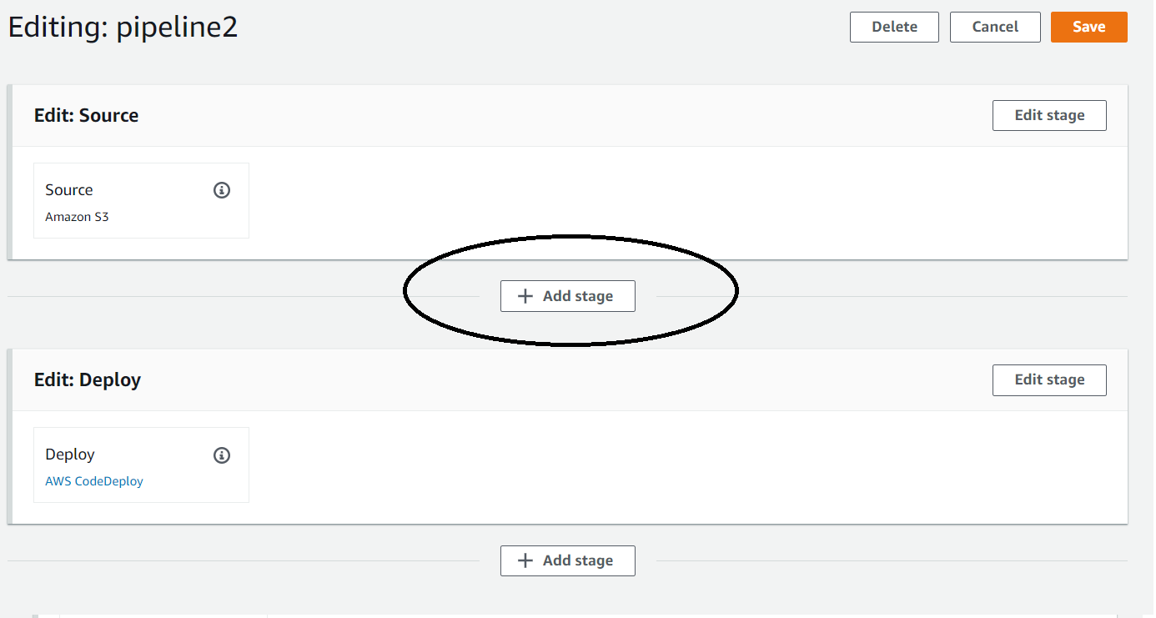
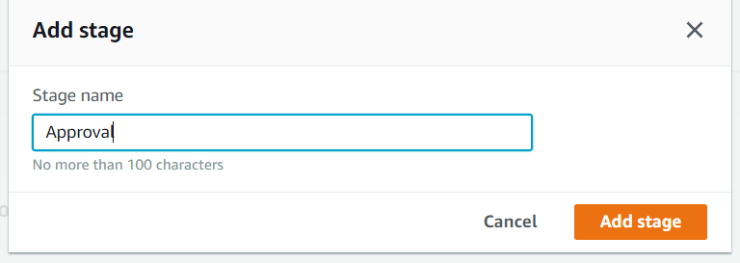
www.vishwacloudlab.com
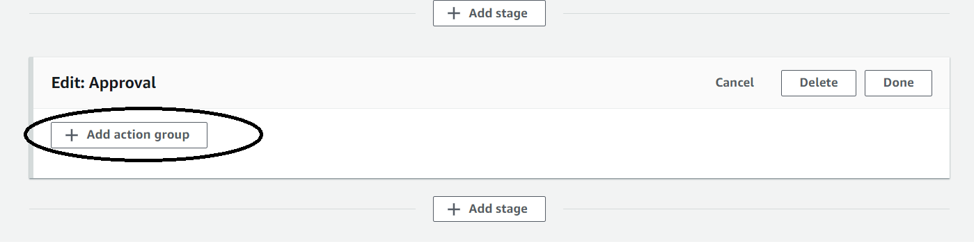
Click on "Action Group"
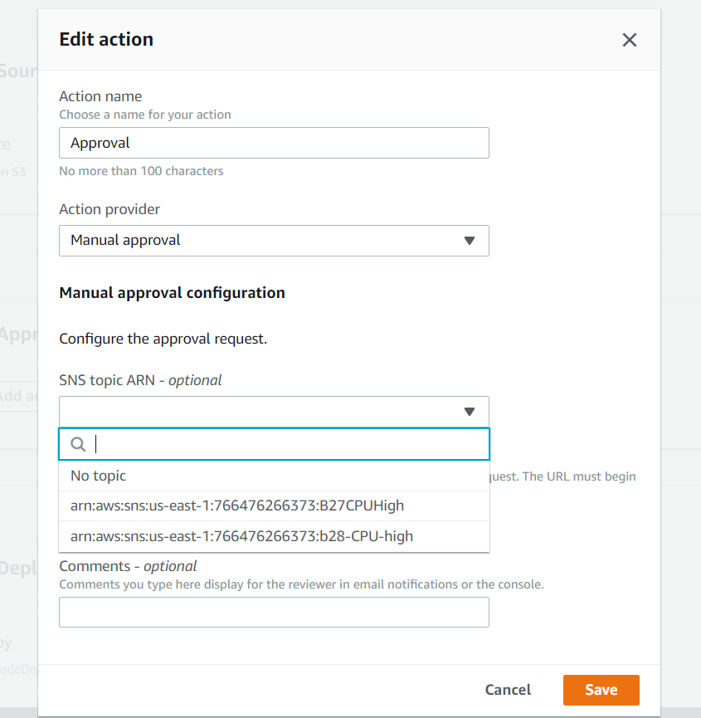
www.vishwacloudlab.com
In this case, we would be selecting "Manual Approval"
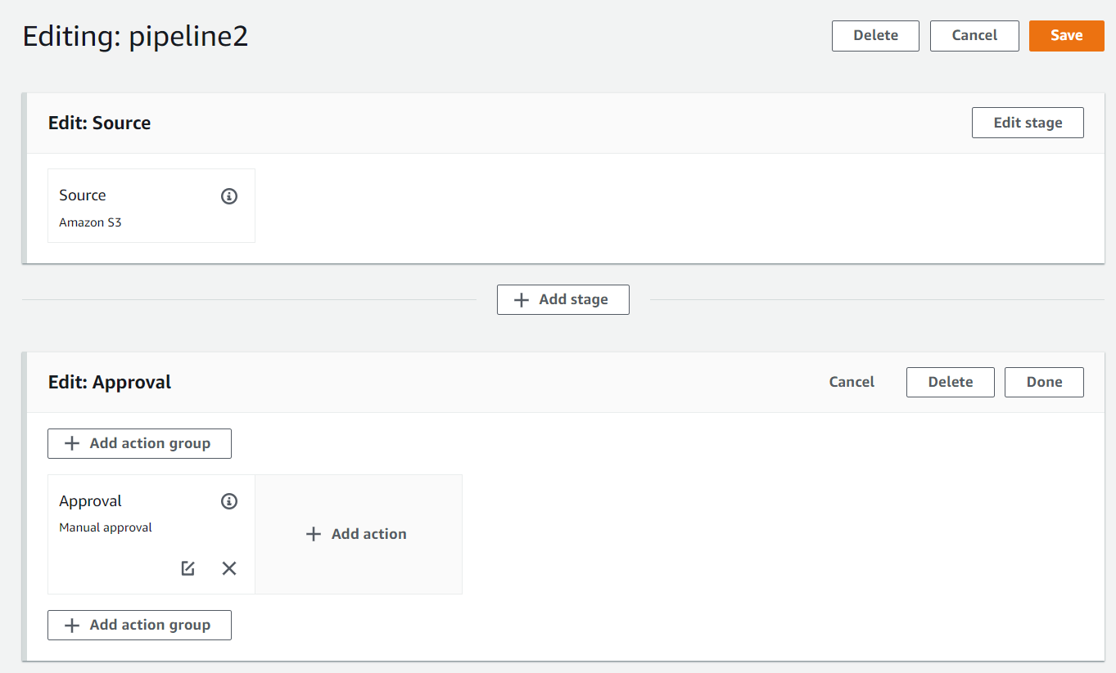
www.vishwacloudlab.com
Now Save the config,
The new Codepipeline should look like the below.
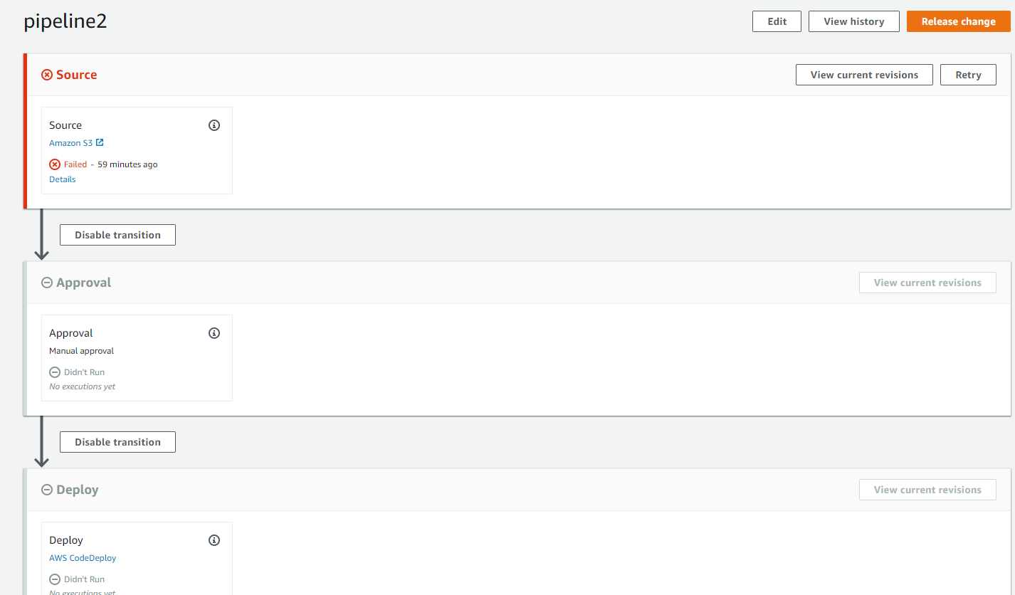
www.vishwacloudlab.com
Similarly.
Add the 4th stage as Approval and
5th Stage as Deployment of the code on the Prod VM as below

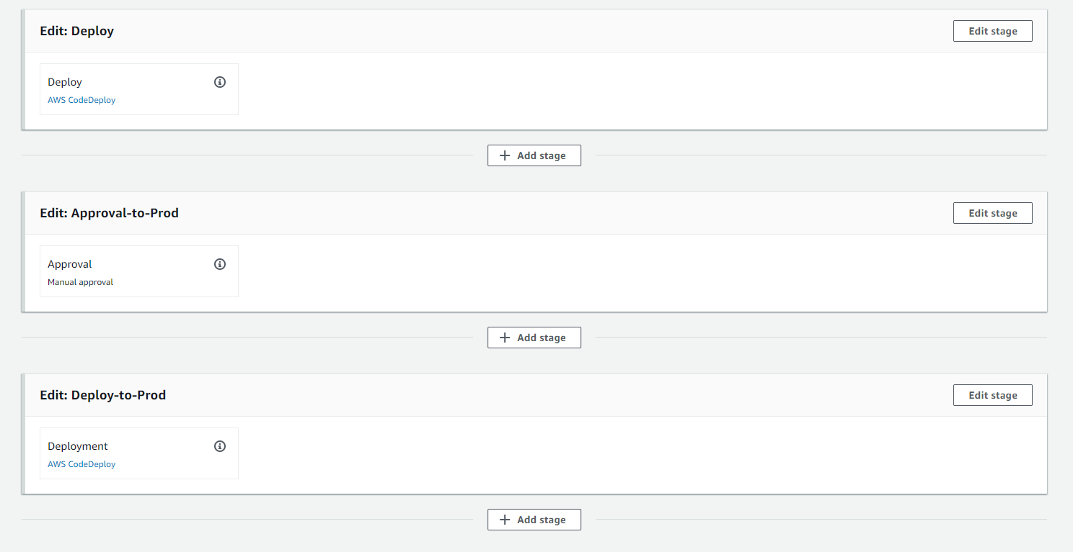
www.vishwacloudlab.com
And then Click on “save” and “Release Change”

3. Update the Source S3 ZIP file.

- Update the index.html file in the “.zip” file, and change “Congratulations” to "Congratulations This is an Updated page” Edit the “appsepc” file. Remove all the lines from “hooks” and save it.
- Then zip the files and upload it as diff version number example, “Sample-linux-v2.zip” . Name of the zip file has to be same.

Note:- Check if the Codepipeline has started automatically.
if NOT.
Click on 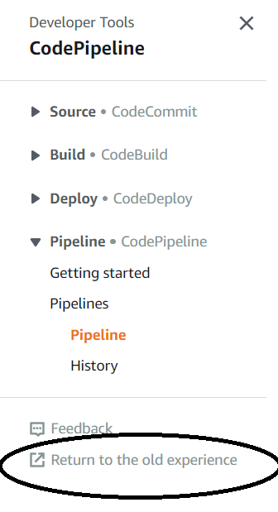
www.vishwacloudlab.com
Choose the codepipeline that was created just now.
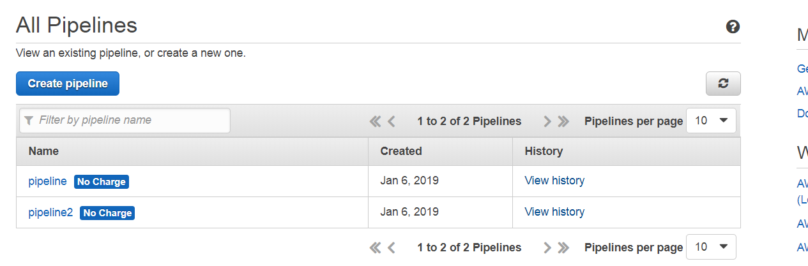
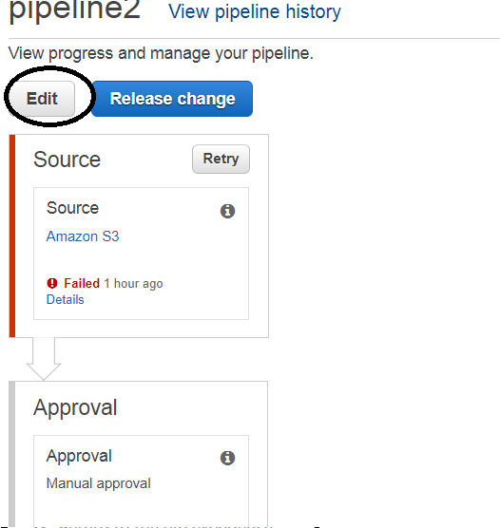
Edit the pipeline.
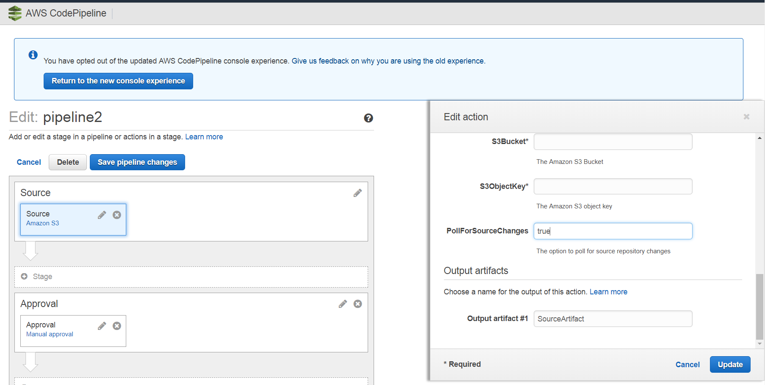
Change the "PoolForSourceChanges" to "true"
Click on "Update"
and Now the Codepipeline should take the new uploaded version of the ZIP file automatically.

